How to use git (windows)

Author | Lori Zhang
Status | Draft
Revision | 2
Last Saved | 10/22/2012 02:46:00 AM

Revision History
Rev | Author | Date | Comments
1 | Lori Zhang | 2012/9/3 | Add some basic information

Overview
Add some common usages.

Common usages

Use Github client

Clone projects from Github to local
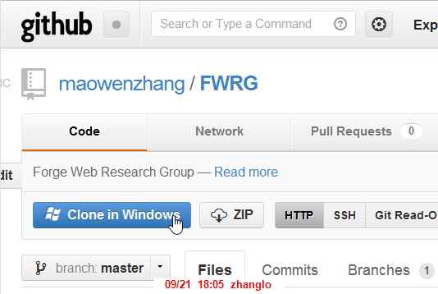
- Clone to local
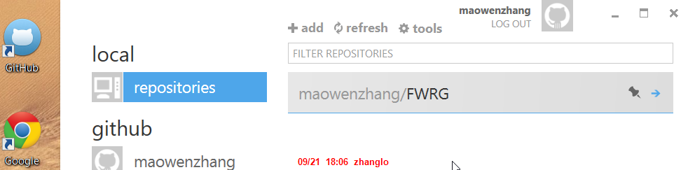
- Start GitHub client, Cloned project in local

Project panel
  - Sync to latest (auto sync)
  - Pending changes (automatically checked by GitHub)
  - Commit history
  - Add message to commit changes
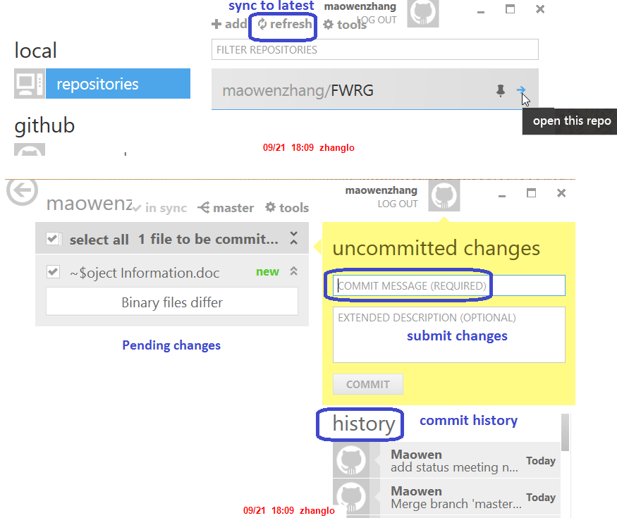

Open related folder/command window
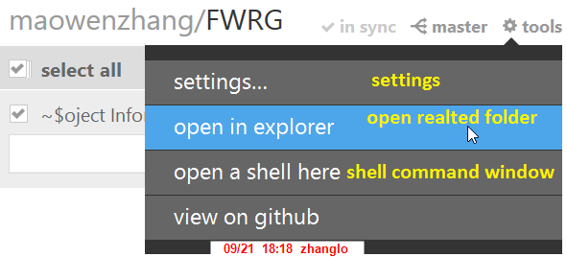

Settings - .gitignore
  - Add folder/files to ignore (file “.gitignore”), for files like output files that don’t need to submit, so they won’t appear in the pending changes list
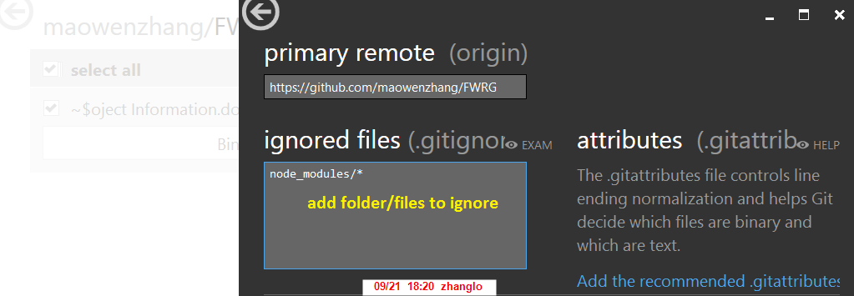

Use command window (GitShell)

Start GitShell command window
- After install GitHub client, two shortcuts will generated (GitHub, GitShell), start GitShell.
  - could set whether use windows powershell or normal one

Clone projects to local
- Type “git clone https://github.com/maowenzhang/FWRG fwrg”
  - Clone this project including all files to new folder “fwrg” in local
- Type “cd fwrg” to switch to this folder
- Type “git status” showing you the current default branch is “master”

Add changes
- Could use “explorer .” to open related folder, make changes to files
- Type “git status” to check what files are changed
- Type “git add .” to add all changed files to pending list (check out)
- Type “git commit –m “message” to commit all changes
- Type “git status” to double check
- Type “git pull” to sync to latest (sync latest from project site to local)
  - It will do merge automatically and show the differences to you
- Type “git push” to final commit change to Github project site

Remove files
- Git rm [file/folder] to delete files
  - Git rm src/res –r
  - Git rm src/*.*

Revert local changes
- Type “git checkout –force” to revert/throw away local changes

Diff files

- 在UserName/bin/ (c:\Users\zhanglo\bin)目录下新建一个git-diff-wrapper.sh
#!/bin/sh
# diff is called by git with 7 parameters:
# path old-file old-hex old-mode new-file new-hex new-mode
"c:\Program Files (x86)\Beyond Compare 2\BC2.exe" "$2" "$5" | cat

- 在UserName/目录下修改.gitconfig文件
[user]
name = Maowen
email = maowen.zhang@hotmail.com
[core]
autocrlf = false
[diff]
external = c:/Users/zhanglo/bin/git-diff-wrapper.sh

- 最后就git diff就ok了。

Most common used commands

Git Commands | Details
Git –help  Git [command] --help | To list all common commands  To get help on specific command
Git status | Check project status, list all uncomment files  Very common use to check pending changes
Git add .  Git add [filename] | Check out all new changed files (or specified file) to pending list
Git commit –m “message” | After using “git add . “, we can use git commit
Git pull  Git push | Git pull is to sync to latest  Git push is to finally commit all changes to project web site

Branch related usages

To add

ERRORs
Git clone https://github.com/kaige/rena
fatal: https://github.com/naglene/MultiView.git/info/refs not found: did you run git update-server-info on the server?

The error means there has no related repo in github.
Case sensitive, should be “Git clone https://github.com/kaige/Rena”

